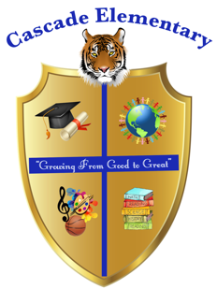

Cascade Elementary Website
Weekly Grade Level News Blast

Week of: Monday, April 13, 2020

Grade Level: Second Grade

Standards of the Week:
ELA: RL7 Use information gained from the illustrations and words in a print or digital text to demonstrate understanding of its characters, setting, or plot.

MATH: MD.10 Draw a picture graph and a bar graph (with single-unit scale) to represent a data set with up to four categories. Solve simple put-together, take apart, and compare problems using information presented in a bar graph.

SCIENCE: S2P1: Obtain, evaluate, and communicate information about the properties of matter and changes that occur in objects.

SOCIAL STUDIES: SS2H1: Describe the lives and contributions of historical figures in Georgia history.

Additional Information for Parents and Students:
There will be a slight change in how virtual learning will be implemented so stay tuned!

